**EXPERIMENT-11**

**AIM: Structuring the data, sorting and filtering tableau data, pivoting tableau data.**

**Structuring Data**

Your organization is having a challenge of dealing with large volume of data. There is no proper flow to understand the data in such volume. we have the the challenge of structuring the data to make it in a proper order for the presentation.

The following are different concepts which can help use to understand the data in such a large volume

a)sorting, b)sets, c)groups, d)bins, e)hierarchies

Create Hierarchy

Hierarchies can be building in Tableau to visualize the data in granular level. Tableau hierarchies can be created by following the given steps.

Step 1) Go to a worksheet.

Select a dimension to create a hierarchy. Right-click on the dimension.

Select ‘Hierarchy’ option.

Click on ‘Create hierarchy’ option  
 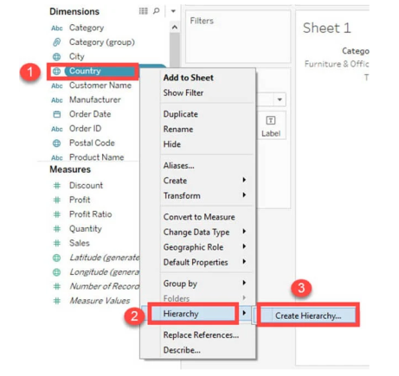

**Step 2)** It opens the ‘Create Hierarchy’ Window.

1. Enter a name for hierarchy.
2. Click on OK

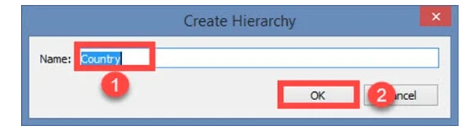

It creates a Hierarchy as shown in the image.

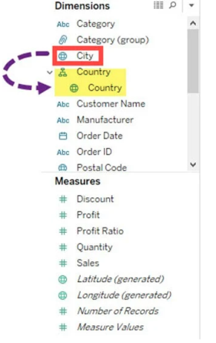

**Build Sets**

Sets create a set of members out of the field present in a data set. It acts as a separated field or dimension. The procedure to build sets is given as follows.

**Step 1)** Go to a Worksheet.

1. Right-click on a dimension.
2. Select ‘Create’ option.
3. Click on ‘Set’ option.

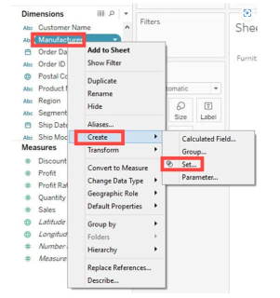

**Step 2)** It opens ‘Create Set’ Window.

1. Name the set to be created.
2. Select the members needs to be added in the set.
3. Click on OK.

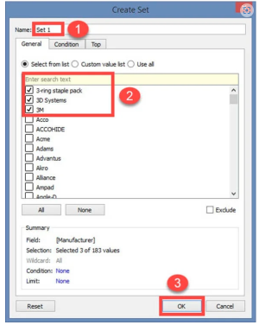

# Filter Data from Data Sources

Data source filters can be useful for restricting the data users can see when you publish a workbook or data source. When you publish a data source to Tableau Server, the data source and any associated files or extracts are transported in entirety to the Server.   
Create a data source filter

The primary way to create a data source filter is from the data source page

To create a data source filter

1. On the data source page, click Add in the Filters section in the upper-right corner of the page

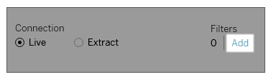

To create a data source filter on a worksheet, right-click (control-click on a Mac) the data source and choose **Edit Data Source Filters**.

Whether you start from the Data Source page or from a worksheet, you see an Edit Data Source Filter dialog box, listing any existing data source filters.

1. Click **Add** to open an Add Filter dialog box listing all fields in the data source.
2. Click to select a field to filter; then specify how the field should be filtered, just as you would for a field on the Filters shelf.

To add an additional data source filter, repeat this procedure

# Tableau Data Sorting

In the data source, data can be stored based on the user requirement. It can be sorted using data source order such as **A to Z ascending**, **Z to A descending**, **A to Z ascending per table** and **Z to A descending per table**.

Once the data is connected with Tableau, data sorting is done using the **Sort Fields** option. The **Sort Fields** option is present in the **Data Source** tab.

There are two ways to sort the data in Tableau:

1. **Manual sorting:** Manual sorting is a sort that rearranges the order of dimension fields by dragging them next to each other in **ad hoc** fashion.
2. **Computed sorting:** The computed sorting is a sort which is directly applied on the axis using the sort dialog button.

